**How to Calibrate Software Configurable Solderless Bread boards:**

These steps can also be used to calibrate any external resistor divider that might be used in conjunction with a data acquisition board that is controlled using the ALICE Universal software. It is strongly recommended that you read and understand this **entire document** before attempting to calibrate your target hardware.

**Required Material:**

1. A Digital Multimeter (hand-held DMM).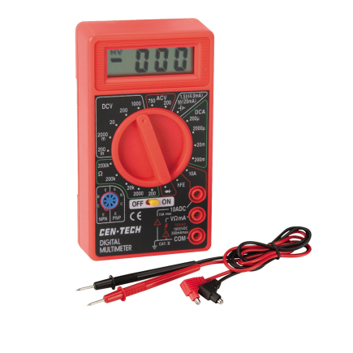

**On Board Voltage Reference Value:**

This step is generally a good idea even when not using input voltage dividers. The RP-2040 microcontroller on the board uses the 3.3V VDD LDO power supply voltage as the reference for the ADC. If the external DAC is included it has its own internal reference voltage (4.096 V). The on board 3.3 V LDO is generally accurate to +/- 20 mV. As a first check it is recommended to measure this voltage using the DMM. The 3.3V supply voltage can be measured on the right most pin of jumper jpVDD4 as shown in figure 1.

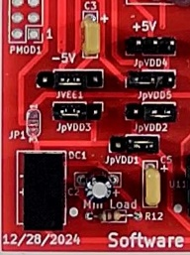

jpVDD4

Left most pin is GND Right most pin is +3.3V

Figure 1, Where to measure 3.3V supply voltage.

The Interface Level .py file(s) contains a variable that the ALICE software uses to “calibrate” the raw voltage measurements. You can edit this file and adjust these variables to reflect your measured results. For example, open the Pico_crosspoint-mini-red.py file in an editor and scroll down and change this line from the default value:

ADC_Cal = 3.299

The ADC_Cal variable adjusts the ADC input voltage conversion factor.

The AWGPeakToPeak variable adjusts the DAC output voltage conversion factor and can generally be left set to the default value of 4.095.

The next step is to adjust the Scope input resistor divider Offset voltage using RV1 as shown on the left side of figure 2. The Scope Input and AWG Output 2X8 pin female header is shown on the right side along with the six voltage divider resistors. Generally the Low sides of the resistor dividers are shorted to the offset voltage as shown using jumpers.

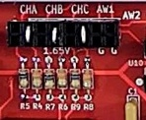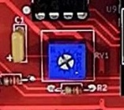

Offset Voltage Adjust Pot

Offset Voltage on left 6 pins of bottom row

Ground is on the right 2 pins of bottom row

AWG 1 Output Voltage

Figure 2, Adjusting the Offset Voltage.

Conned the DMM across any one of the two Ground pins and any one the 6 Offset voltage pins. The 680kΩ / 330kΩ resistor divider ratio is 1010/330 or 3.06. Multiplied by the 0 to 3.3 V ADC input range gives a P-P range of 10.1 V total. By adjusting the Offset voltage to 2.5 V we can center this range on 0V for a measurement range of approximately -5 V to +5 V which is perfect for the +/- 5V power supply of the Matrix analog switches. Adjust RV1 for a reading of 2.500 V on the DMM.

**Using the ALICE software Gain and Offset adjustment settings:**

The first step is to open the Input divider calculator by clicking on the Adjust Gain / Offset button. The Divider calculator tool screen will open as shown in figure 3.

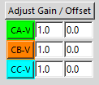

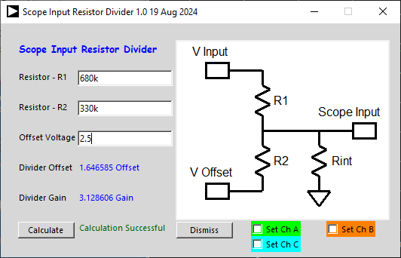

Figure 3, Input divider calculator.

Enter values for R1, 680k and R2, 330k and the offset voltage, 2.5. Click the Calculate button. The offset and gain values will now be filled in. To transfer these values to the Ch A, Ch B and Ch C entries click on the three Set check boxes. These approximate values should now be populated as shown.

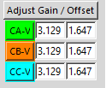

These values are of course only approximately correct for your specific board given the tolerance in the actual resistor values used on your board. The next step is to calibrate (adjust) the actual Gain and Offset values.

We will be using the AWG1 signal generator output as our calibration standard. We can use the Cross Point switches to connect the Scope inputs to the AWG1 output using the Cross Point Interface Screen. We can connect the three Scope inputs (AINH, BINH and CINH) and the AWG output (AWG1) together using Jumper JP1. Enter JP1 in Jumper, and 1 in On/Off. To connect the AWG1 output to jumper JP1 enter AWG1 in Comp Pin. Click the Set button. Repeat for the three Scope inputs by entering AINH, BINH and CINH for Comp Pin one at a time and click the Set button.

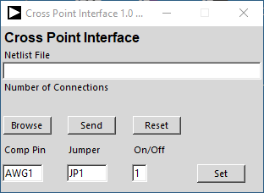

Enter Name of Component Pin Here

Enter Name of Jumper Here

Enter

1 to close switch connection

0 to open switch connection

Click Set to make / break connection

Reset opens all switches

The three Scope input channels should now be connected to the AWG1 signal generator output.

Now we need to configure the AWG CH A settings as per the figure below. Set the waveform shape to Sine. Set the Low V value to 0.0 (the DAC minimum output voltage). Set the High V value to 4.0 (a close to full scale round number for the DAC). The Freq can be set to just about any value but 300 Hz is a good number. Click the AWG A Output OFF button to ON to start generating the waveform.

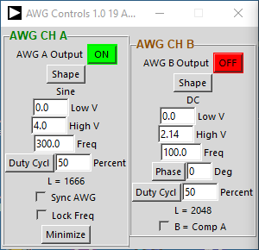

Set Shape to Sine

Set Low V to 0.0

Set High V to 4.0

Set Freq to 300

With just the CH A, CH B and CH C traces selected, Click Run. Use CH A as the trigger source and center the trigger level on the waveform. Adjust the channel range and position settings to center the waveforms on the screen. 500mV/div and 2.5 for the Pos are good options. A time scale of 1mS / Div is also a good setting. Turn on trace averaging using the ‘a’ key on the key board.

We first want to adjust the Gain for each channel such that the peak to peak value matches the 4 Vp-p from the AWG generator. From the Meas drop down menus select p-p for all three channels. Tweak the values in the Gain entries for each channel until you measure as close to 4.00 V p-p as possible.

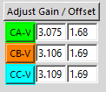

Tweaked Values

To adjust the offset we need to set the AWG output to 0V DC. Change the waveform shape to DC and the High V value to 0.0. From the Meas drop down menus select Avg for all three channels. Tweak the values in the Offset entries for each channel until you measure as close to 0.00 V avg as possible.

Your Scope input channels should now be calibrated to match the accuracy of the DAC.

These adjustment settings are automatically saved in the alice-last-config.cfg file along with all the other configuration settings each time you exit ALICE. You can also save just the input gain and offset adjustment values in a separate file by clicking on the Save Adj button in the File Drop down menu. Clicking on the Load Adj button will load the saved values from the file.

**Appendix:**

For additional accuracy the DAC Full Scale voltage can be checked with the DMM. Set the AWG A High V to 4.00 and the Shape to DC. The DAC output can be accessed on the upper row second from the right pin as in figure 2. When calibrating the Input channel gain we assumed that the DAC output was exactly 4.00 V p-p. Using this actual measured peak voltage for the DAC output will provide a more accurate calibration.